SIMATS ENGINEERING

ASSESSMENT TOOL 2

COURSE NAME: Database Management Systems

COURSE CODE: CSA0501

NAME: Mukesh Raj L

REGISTER NUMBER:192571036

COURSE OUTCOME COVERED

CO1: Analyze DBMS architecture, different data models, schema types, and design ER/EER diagrams, relational schemas for case-based scenarios by identifying entities and relationships. (BL1, BL2)

Activity Tool : Concept Mapping (Medium) Assessment Tool Weightage: 35%

QUESTIONS Total Marks: 50
Q.No | Question | Bloom's Level | Marks
1 | Construct a concept map linking the following terms: DBMS, Schema, Instance, Data Model, ER Diagram, Entity, Attribute, Relationship. | BL2 – Understand | 5
2 | Create a concept map for the three-level ANSI/SPARC architecture showing data independence at each level. | BL2 – Understand | 5
3 | Map the relationship between file-based systems and database systems, highlighting the problems solved by DBMS. | BL2 – Understand | 5
4 | Design a concept map for ER diagram components: entity, weak entity, attribute types, relationship types, and participation constraints. | BL2 – Understand | 5
5 | Construct a concept map comparing Hierarchical, Network, and Relational data models with their key properties. | BL2 – Understand | 5
6 | Develop a concept map for the EER model showing how it extends the basic ER model with generalization, specialization, and aggregation. | BL2 – Understand | 5
7 | Create a visual concept map for the DBMS software architecture, illustrating the flow from user request to data retrieval. | BL2 – Understand | 5

8 | Map the data models discussed in CO1 to real-world applications and explain the suitability of each model. | BL2 – Understand | 5
9 | Construct a concept map for schemas and instances, showing how they relate to physical and logical data independence. | BL2 – Understand | 5
10 | Design a concept map for the roles and responsibilities in a DBMS environment: DBA, End User, Application Developer. | BL1 – Remember | 5

Code of Conduct:

I Mukesh Raj L(192571036) certify that this submission is my original work and that I have adhered to the guidelines specified for this assessment. I understand that any violation of academic integrity rules will result in disciplinary action.

Signature of the student:


RUBRICS FOR CALCULATION:

Criteria | Weightage | Level 4 (Exemplary) | Level 3 (Proficient) | Level 2 (Developing) | Level 1 (Beginning)
Concept Identification | 25% | Identifies all key concepts from literature accurately and comprehensively | Identifies most key concepts with minor omissions | Identifies limited concepts; some are irrelevant or missing | Fails to identify essential  concepts
Linkages | 25% | Establishes clear, meaningful, and accurate relationships between concepts | Shows correct relationships with minor gaps | Relationships are weak, unclear, or partially incorrect | No meaningful relationships established
Organization | 20% | Concepts are well-structured hierarchically with logical flow and grouping | Mostly organized with minor structural issues | Some organization but lacks clear hierarchy | No logical organization or structure
Integration of Literature | 20% | Integrates multiple studies effectively to  show connections and comparisons | Shows some integration of literature | Limited integration; mostly isolated concepts | No integration of literature evidence

Clarity | 10% | Concept map is clear, neat, visually structured, and easy to interpret | Generally clear with minor readability issues | Clarity is reduced; difficult to interpret in parts | Poorly presented and hard to understand

1)

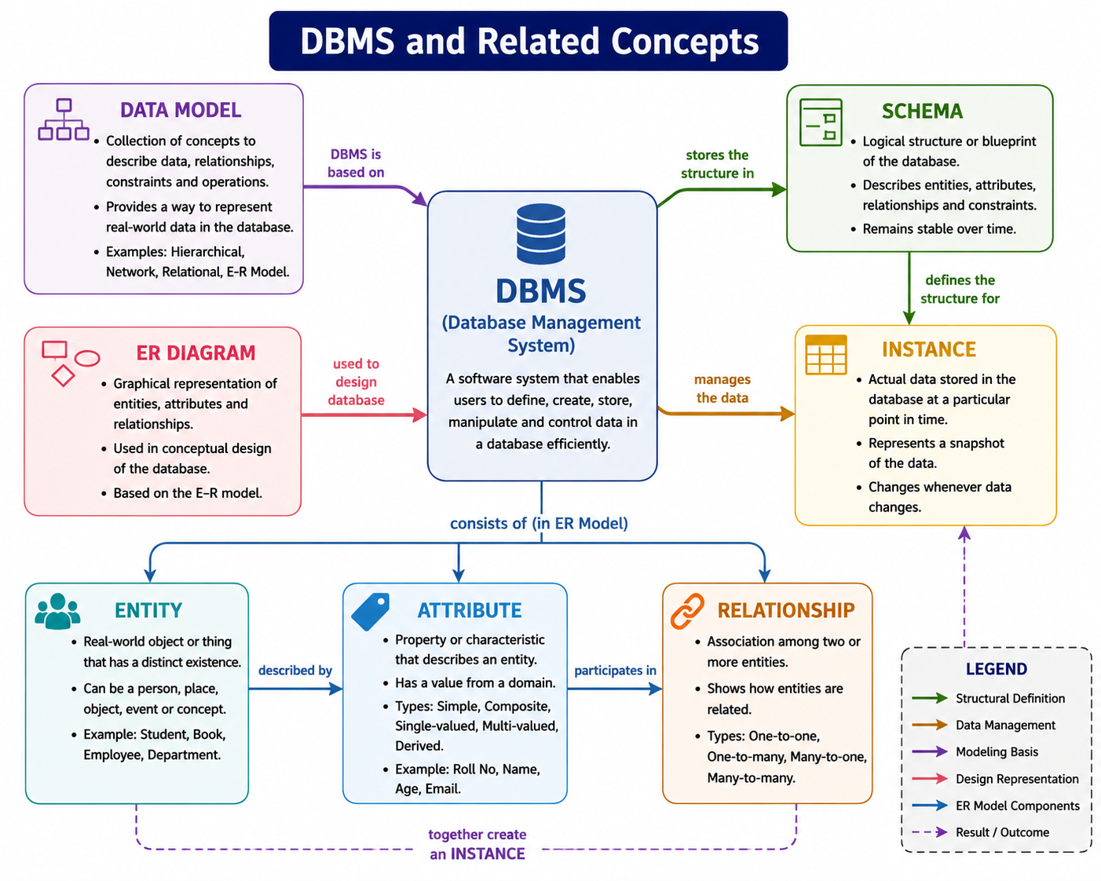

Explanation
The concept map illustrates the relationship between the Database Management System (DBMS) and its fundamental concepts. A Data Model provides the framework for organizing data, while the Schema defines the logical structure of the database. The ER Diagram represents entities, attributes, and relationships during database design. Entities are real-world objects, Attributes describe their properties, and Relationships connect entities. An Instance represents the actual data stored in the database at a specific point in time.

2)
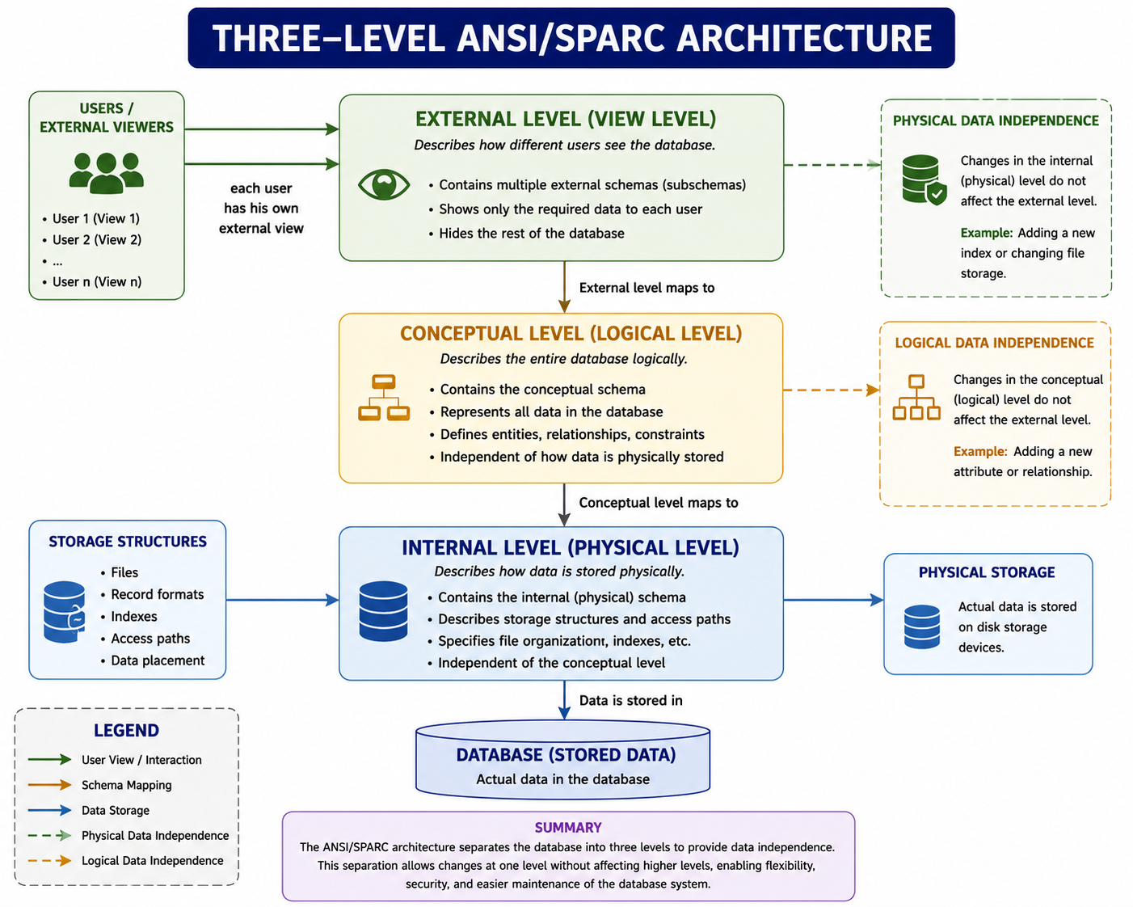

Explanation
The ANSI/SPARC three-level architecture organizes a database into External, Conceptual, and Internal levels. The External Level provides customized views for different users, the Conceptual Level defines the overall logical structure of the database, and the Internal Level manages the physical storage of data. This architecture supports Logical Data Independence, where changes to the conceptual schema do not affect user views, and Physical Data Independence, where changes in physical storage do not affect the conceptual schema. As a result, it improves flexibility, security, and maintainability of the database system.

3)
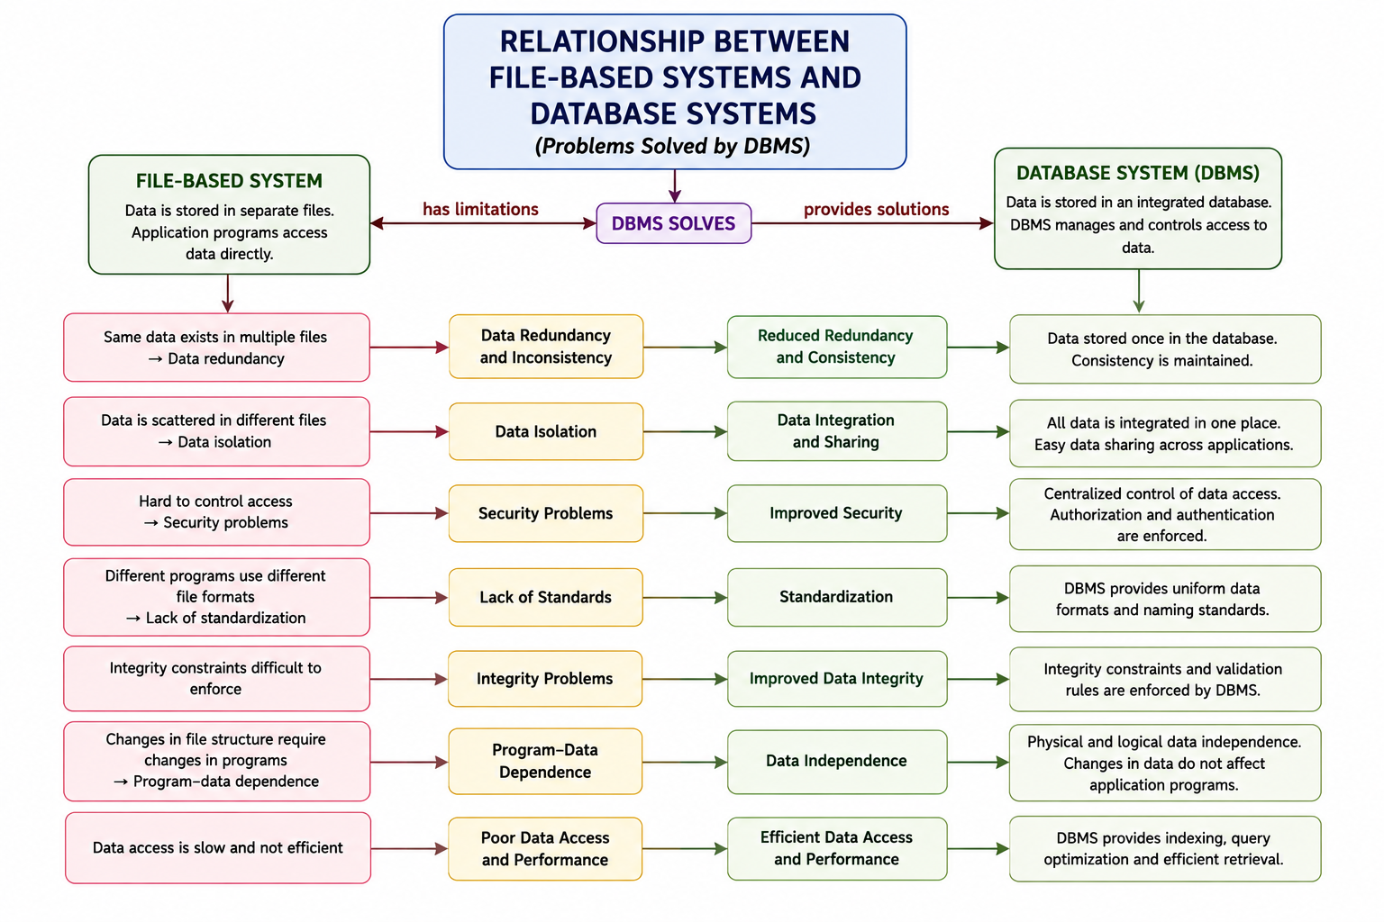

Explanation
The concept map compares the File-Based System with the Database Management System (DBMS) by highlighting the limitations of file-based systems and the solutions provided by DBMS. File-based systems suffer from data redundancy, inconsistency, data isolation, security issues, program–data dependence, and inefficient data access. A DBMS overcomes these problems by providing centralized data management, reduced redundancy, data sharing, improved security, data integrity, data independence, and efficient data retrieval. This makes DBMS a more reliable, secure, and efficient system for managing data.

4)
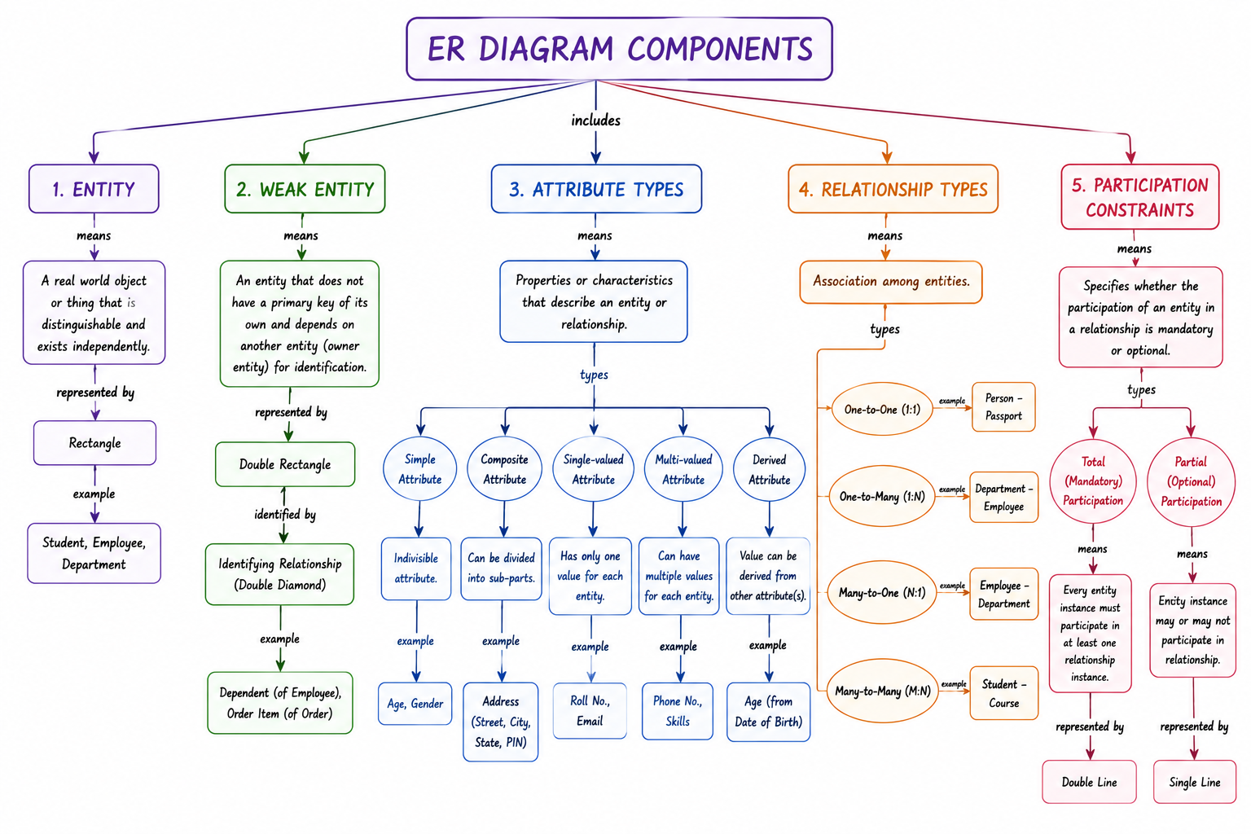

Explanation
The concept map illustrates the main components of an ER (Entity–Relationship) Diagram. An Entity represents a real-world object, while a Weak Entity depends on another entity for identification. Attributes describe the properties of entities and are classified as simple, composite, single-valued, multi-valued, and derived attributes. Relationship Types define how entities are associated, such as one-to-one, one-to-many, many-to-one, and many-to-many. Participation Constraints specify whether an entity's participation in a relationship is total (mandatory) or partial (optional), helping to accurately model real-world database requirements.

5)
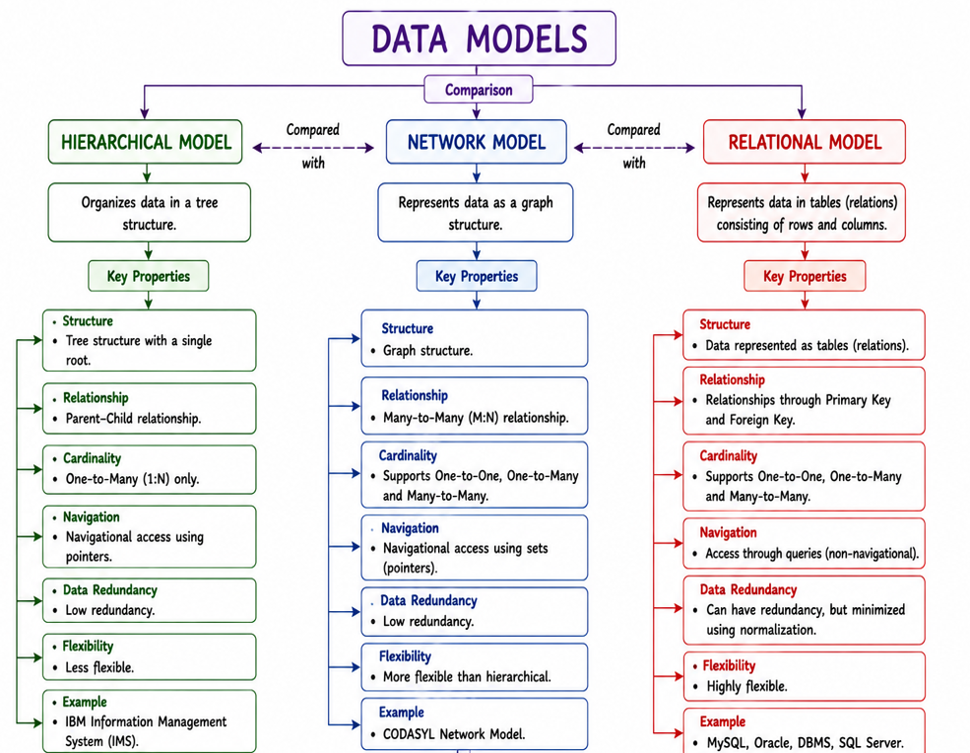

Explanation
The concept map compares the Hierarchical, Network, and Relational data models based on their structure and key properties. The Hierarchical Model organizes data in a tree structure with one-to-many parent–child relationships. The Network Model uses a graph structure that supports many-to-many relationships, making it more flexible than the hierarchical model. The Relational Model stores data in tables (relations) and uses primary and foreign keys to establish relationships. Among these, the relational model is the most widely used because of its simplicity, flexibility, and efficient data management.

6)
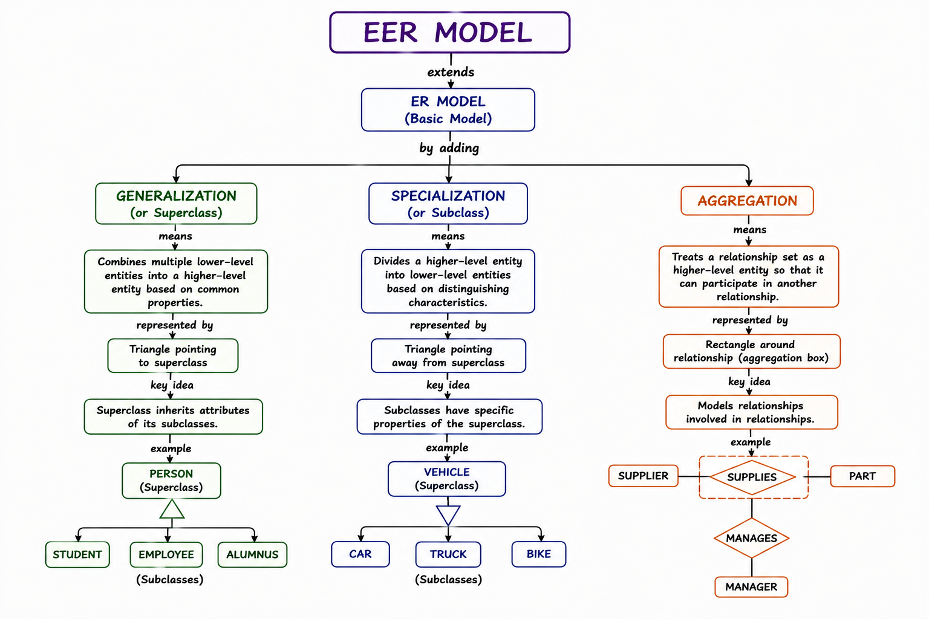

Explanation
The Enhanced Entity–Relationship (EER) Model extends the basic ER Model by introducing advanced modeling concepts such as Generalization, Specialization, and Aggregation. Generalization combines similar lower-level entities into a higher-level superclass based on common characteristics, while Specialization divides a superclass into more specific subclasses according to distinguishing features. Aggregation treats a relationship as a higher-level entity, enabling it to participate in other relationships. These enhancements make the EER model more effective for representing complex real-world database scenarios.

7)
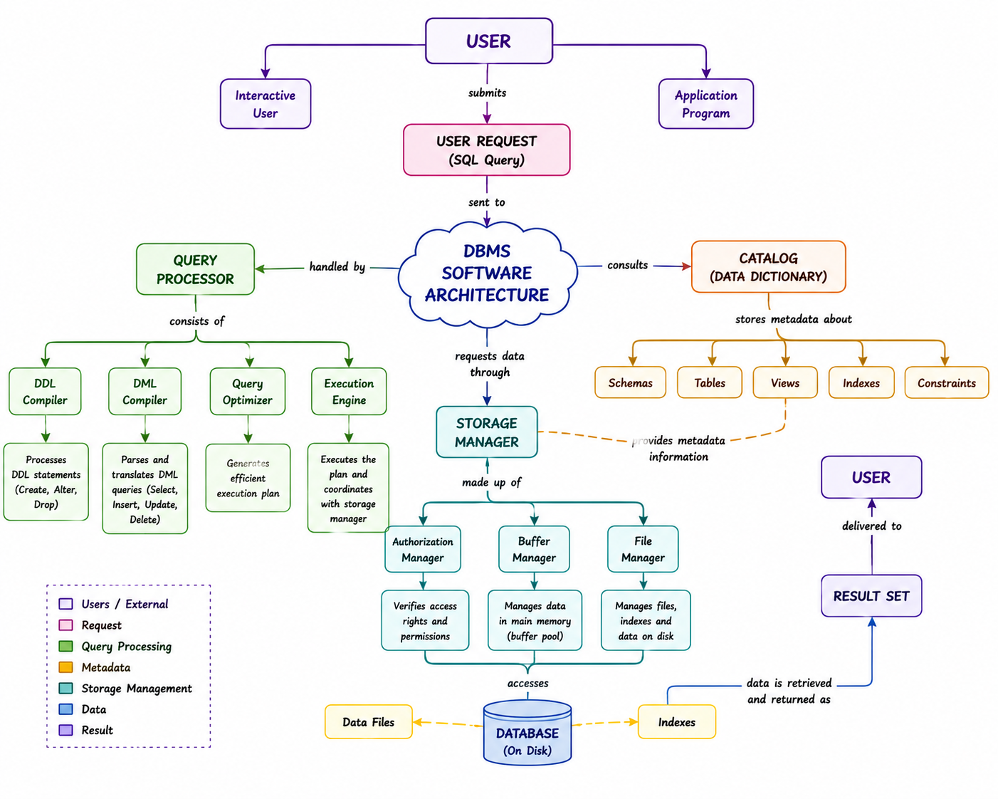

Explanation
The concept map illustrates the DBMS software architecture and shows how a user request is processed to retrieve data from the database. When a user submits an SQL query, the Query Processor interprets, optimizes, and executes the request with the help of components such as the DDL Compiler, DML Compiler, Query Optimizer, and Execution Engine. The Data Dictionary (Catalog) provides metadata, including information about schemas, tables, views, indexes, and constraints. The Storage Manager, consisting of the Authorization Manager, Buffer Manager, and File Manager, accesses the database files to retrieve the required data. Finally, the result set is returned to the user, ensuring efficient, secure, and accurate data retrieval.

Bottom of Form
8)
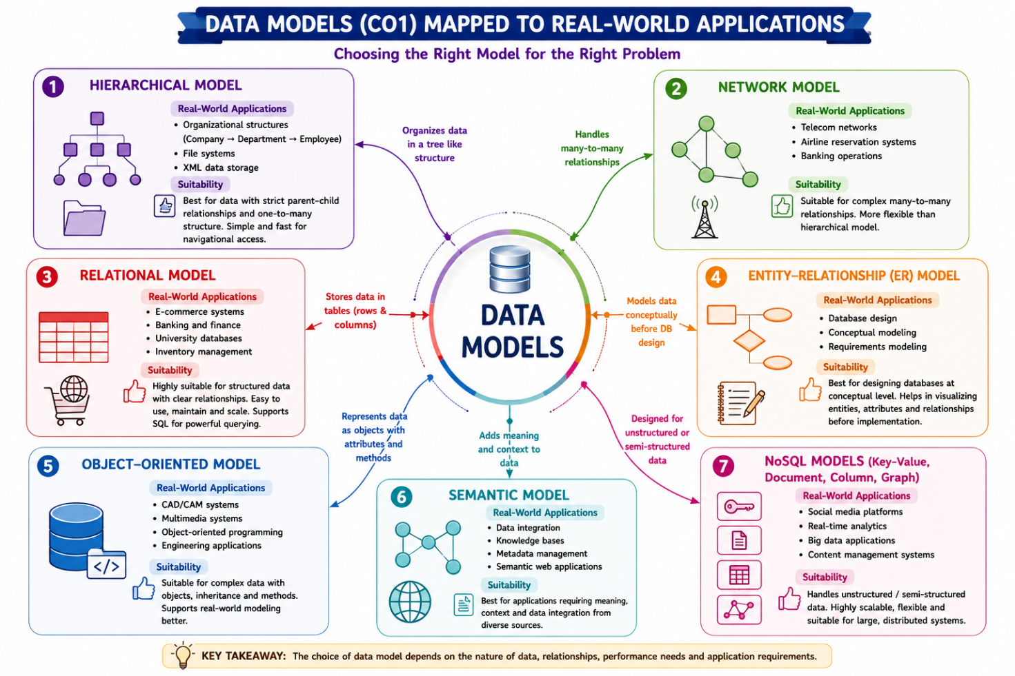

Explanation
The concept map relates the data models studied in CO1 to their real-world applications and highlights the suitability of each model. The Hierarchical Model is suitable for applications with parent–child relationships, such as file systems and organizational structures. The Network Model is ideal for complex many-to-many relationships found in telecommunication and airline reservation systems. The Relational Model is widely used in banking, e-commerce, university, and inventory systems because it stores data in tables and supports efficient SQL queries. The ER Model is used during conceptual database design to represent entities and relationships before implementation. Overall, selecting the appropriate data model depends on the type of data, relationships, and application requirements

9)
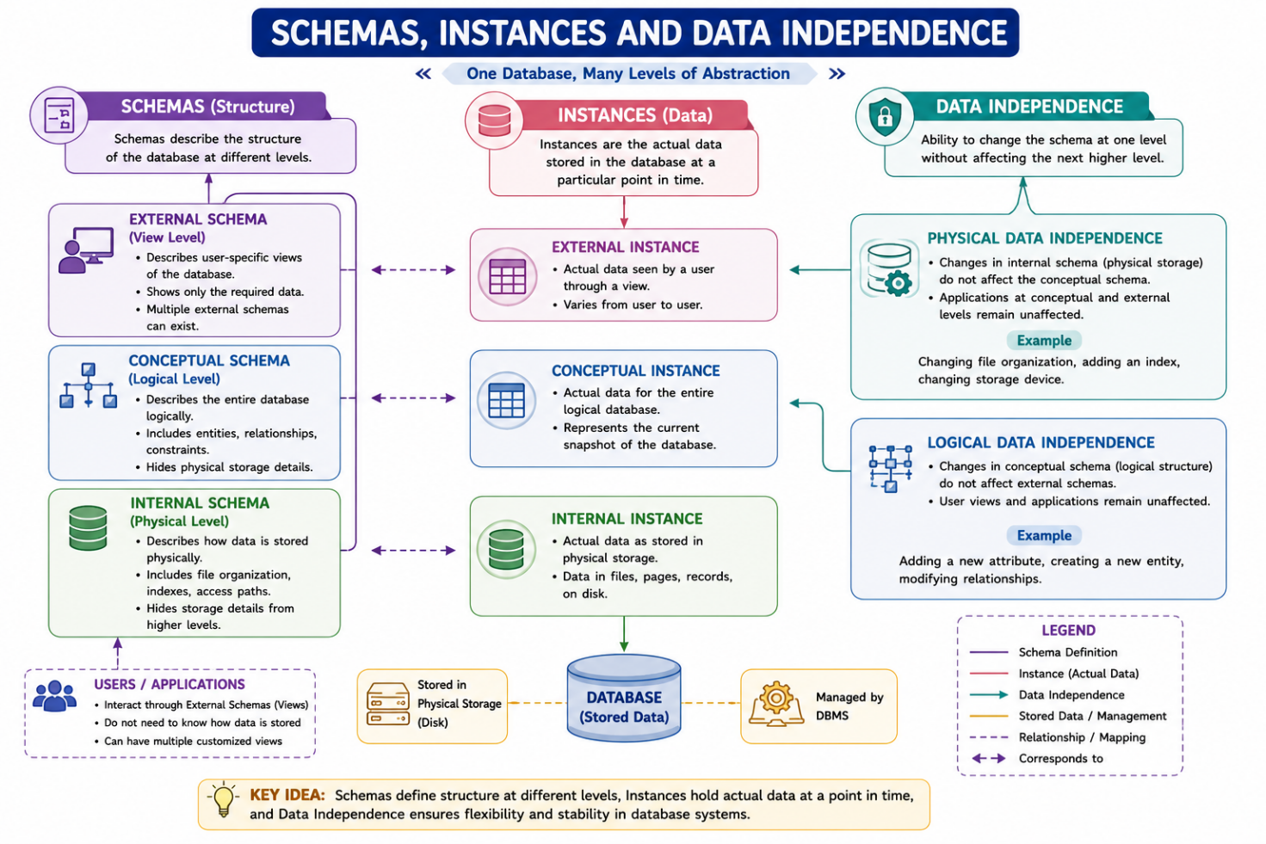

Explanation
The concept map illustrates the relationship between Schemas, Instances, and Data Independence in a DBMS. A Schema defines the logical structure of the database, while an Instance represents the actual data stored at a specific point in time. Physical Data Independence allows changes to the internal (physical) storage without affecting the conceptual schema, whereas Logical Data Independence allows changes to the conceptual schema without affecting external user views or application programs. These features provide flexibility, simplify database maintenance, and ensure efficient data management.

10)
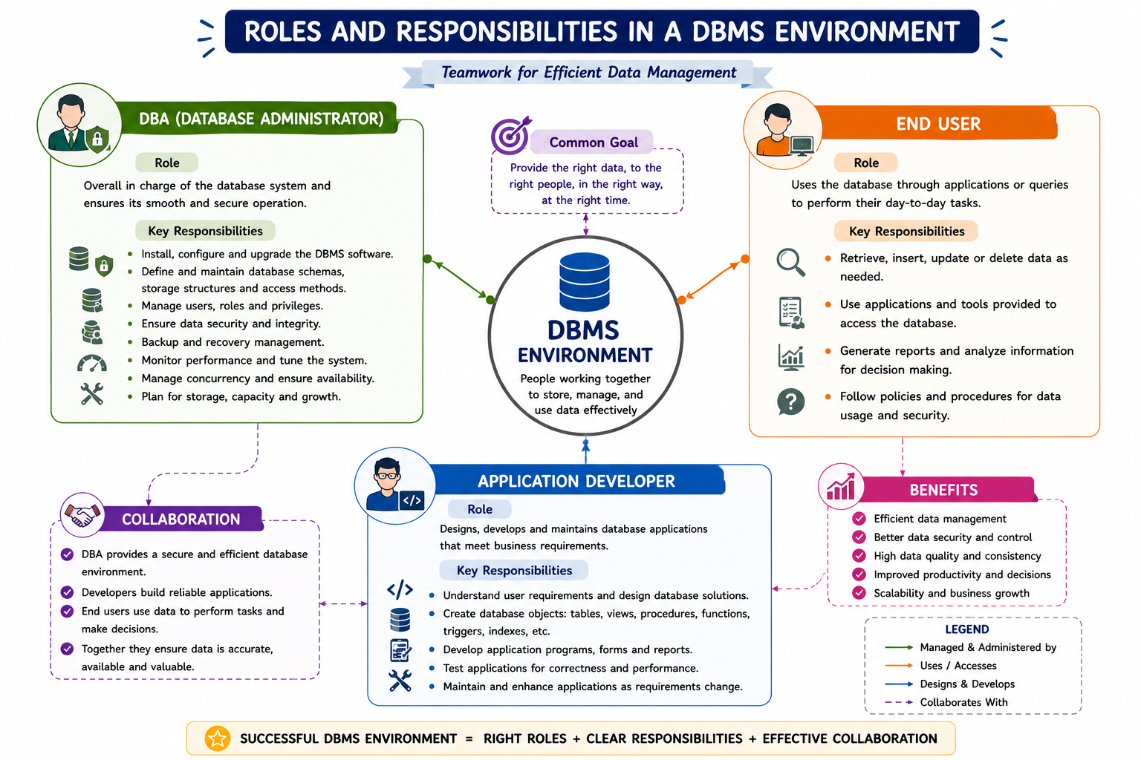

Explanation
The concept map illustrates the roles and responsibilities of the three main participants in a DBMS environment: the Database Administrator (DBA), Application Developer, and End User. The DBA is responsible for database installation, security, backup, recovery, performance tuning, and user management. The Application Developer designs and develops database applications, creates database objects, and maintains application functionality. The End User interacts with the database through applications to retrieve, insert, update, and analyze data. Together, these roles ensure efficient database management, secure data access, and reliable application performance.

